A Technical Report Submitted

by

RITWICK GHOSH

COLLEGE ROLL- CSE/20/013

UNIVERSITY ROLL- 10700120025

**DEPARTMENT OF COMPUTER SCIENCE & ENGINEERING**

**COLLEGE OF ENGINEERING & MANAGEMENT, KOLAGHAT**

***CONTENTS***

|  |  |  |
| --- | --- | --- |
| **Serial No.** | **PARTICULARS** | **Page No.** |
| 01 | PROJECT OBJECTIVE | 06 |
| 02 | INTRODUCTION | 07 |
| 03 | ADVANTAGES OF UNIVERSAL JOINT | 08 |
| 04 | DISADVANTAGES OF UNIVERSAL JOINT | 08 |
| 05 | APPLICATIONS OF UNIVERSAL JOINT | 08 |
| 07 | DESCRIPTION OF EACH PART | 09-11 |
| 09 | DESIGNING PARTS | 11-18 |
| 10 | PROJECT PICTURES | 19-22 |
| 11 | CONCLUSION | 23 |

***PROJECT OBJECTIVE***

The objective of the training in **“AutoCAD 2D & 3D”** is to learn how to create basic 2D drawings then gradually complex 3D drawings in the AutoCAD software. The AutoCAD software is one of the most sophisticated computer applications that we are likely to encounter. Therefore, learning to use it can be challenging. Learning AutoCAD to use daily for drawing creation and editing, or simply need to under­stand how to navigate around a drawing file, this training provided me all.

A **“Universal coupling”** is a special type of coupling in which misalignment of shafts is allowed. Shafts are free to move any direction in order to transmit torque or power from one shaft to another. Hence I tried to design **“Universal Joint”** in **“AutoCAD 3D modeling.”**

***INTRODUCTION***

A “**Universal Joint**” also known as “**Universal Coupling**” or “**U Joint**” or “**Cardan Joint**” or “ **Hardy-Spicer Joint**” or “**Hooke’s Joint**.” “**Universal Joint**” is a joint or coupling in a rigid rod that allows the rod to ‘bend’ in any direction, and is commonly used in shafts that transmit rotary motion. It consists of a pair of hinges located close together, oriented at 90o to each other, connected by a cross shaft. The simplest and most common type is called the “**Cardan Joint**” or “**Hooke joint**.”

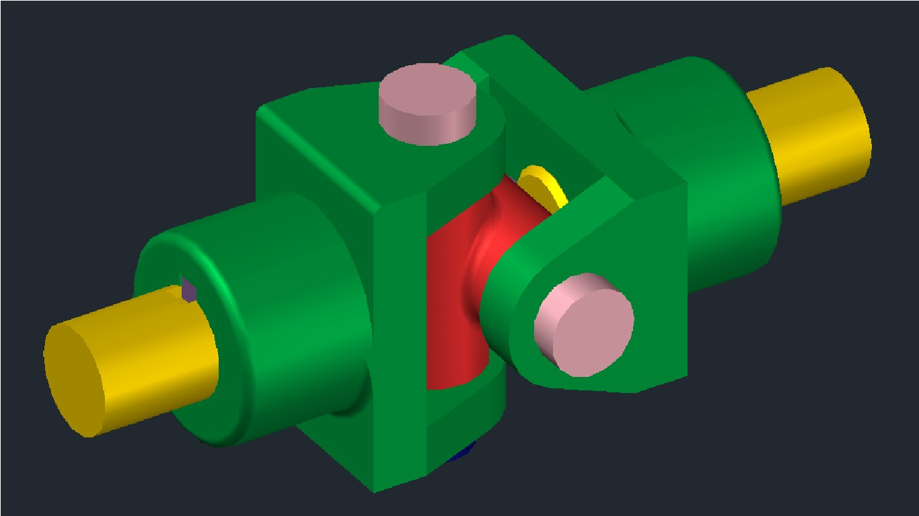

***Advantages of Universal Joint:***

1. Universal coupling is more flexible than knuckle joint.
2. It facilitates torque transmission between shafts which have angular misalignment.
3. It is cheap and cost effective.
4. It is simple to be assembled and dismantled.
5. Torque transmission efficiency is high.
6. The joint permits angular displacements.

***Disadvantages of Universal Joint:***

1. The rotation is not transmitted smoothly and the variation. between the input and output shaft position increases with the angle between the two shafts.
2. Universal joint produces fluctuating motion.
3. It does not support axial misalignment.
4. Wear may occur if the joint is not properly lubricated.

***Applications of Universal Joint:***

Typical applications of universal joints include-

* AUTOMOBILE
* Aircraft
* Appliances
* Control mechanisms
* Electronics instruments
* Medical & optical devices
* Ordinance radio
* Sewing machines
* Textile machineries etc.

***DESCRIPTION OF EACH PART***

A typical Universal joint has the following parts:

1. Fork,
2. Centre Block,
3. Shaft,
4. Key,
5. Pin,
6. 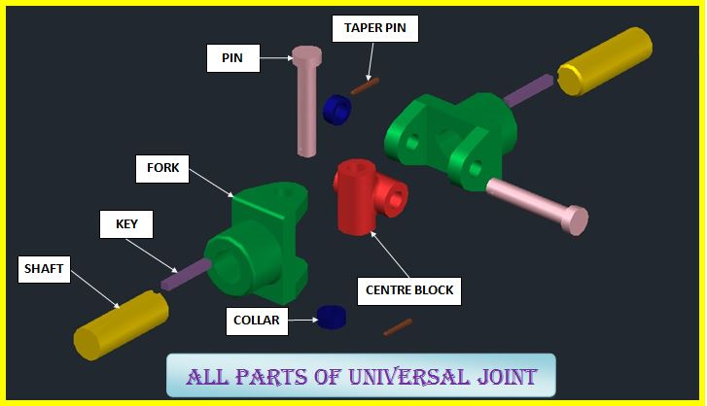Collar,
7. Taper Pin
8. ***Fork:-***

Two Forks are used for providing support to the shafts that are to be connected using the universal joint. A typical fork consists of a central hole to support shaft and a keyway to accommodate shaft key. It also contains two holes to support a pin. Forks are designed in such a manner that they fit accurately over the centre block.

1. ***Centre Block:-***

Centre block is the basic building block of a universal joint. It provides support to the forks used in the joint. It consists of two hollow cylinders joined together at right angles to each other. Holes in the centre block are meant to accommodate pins.

1. ***Shaft: -***

Shaft is the pivoting machine component that will be associated by the all inclusive joint. It is barrel shaped fit as a fiddle. It contains a keyway to suit shaft key.

1. ***Key*:-**

It is utilized to make the all inclusive joint pivot with the pole. It makes the pole to legitimately fit itself in the widespread joint. Shaft key may be straight or decreased.

1. ***Pin:-***

It is a component used for securing the fork to the centre block. It contains a tapered hole to accommodate a taper pin. In a universal joint, two pins are used to connect two forks to the centre block.

1. ***Collar:-***

It is used for securing the location of the pin that is inserted into the fork. It contains tapered holes to accommodate taper pin. In a universal joint, two collars are used to secure two pins.

1. ***Taper Pin:-***

It holds the stick and neckline in the craved area. It keeps the stick from pivoting or moving. This guarantees the unbending nature of the widespread joint.

***DESIGNING PARTS***

***1.Fork:-***

1. Select the view as ‘Top View” and visual style as “2D Wireframe”
2. Draw a rectangle of 16mm×57mm
3. Explode the rectangle
4. Offset the right side line at a distance 18mm
5. Draw a circle at middle point of the line of radius 20mm
6. Draw a tangent from end point of rectangle to the tangent of circle
7. Trim the unwanted extra lines
8. Draw an another circle at the same center of diameter 16mm
9. Change the view as “SE Isometric”
10. Presspull the rectangle of height 84mm
11. Presspull the circular section of height 14mm
12. Copy the circular section and paste at the top of the rectangle
13. Union the 3portion object
14. Erase the 2D drawing
15. Draw a cylinder at the face of the rectangle of diameter 57mm and height 38mm
16. Union the whole object
17. Draw an another circle of diameter 30mm at desired position
18. Draw a line at the top of circle of length 3.5mm and at right side 8mm
19. Move the middle position of horizontal line to the top of vertical line
20. Draw the line from two end point up to the face of circle
21. Draw a horizontal line from the top quadrant point
22. Move the both sides vertical lines up to face of the circle
23. Trim the unwanted extra portions
24. Move to at the of centre point off the cylinder
25. Presspull the circle to remove the material
26. Change the visual style to “Conceptual”
27. Fillet the edge of radius 3mm
28. Change the color to “Flaked Satin-Sea Green”

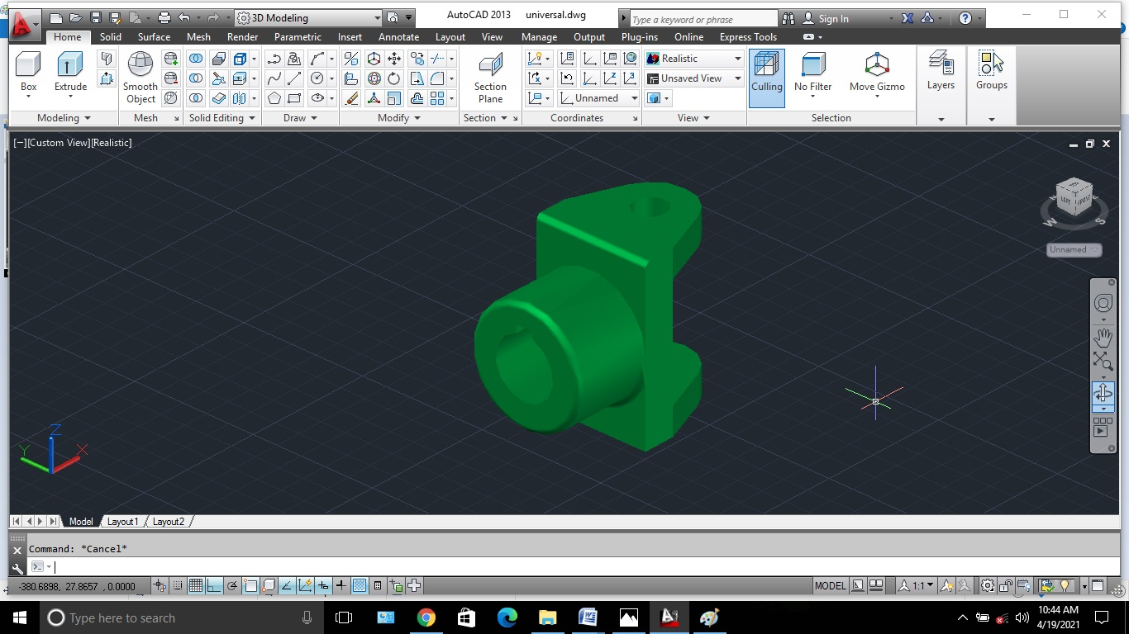

***2.Centre Block:-***

1. Draw a cylinder of diameter 32mm and height 56mm
2. Copy the cylinder and paste to another suitable position
3. Rotate the cylinder at 90o
4. Move the cylinder to another cylinder’s center
5. Move the cylinder 18mm apart
6. Union the objects
7. Draw the two circle at the top of each cylinder
8. Presspull the circle to remove the material
9. Fillet the edge of radius 3mm
10. Change the color to “Satin Light Red”

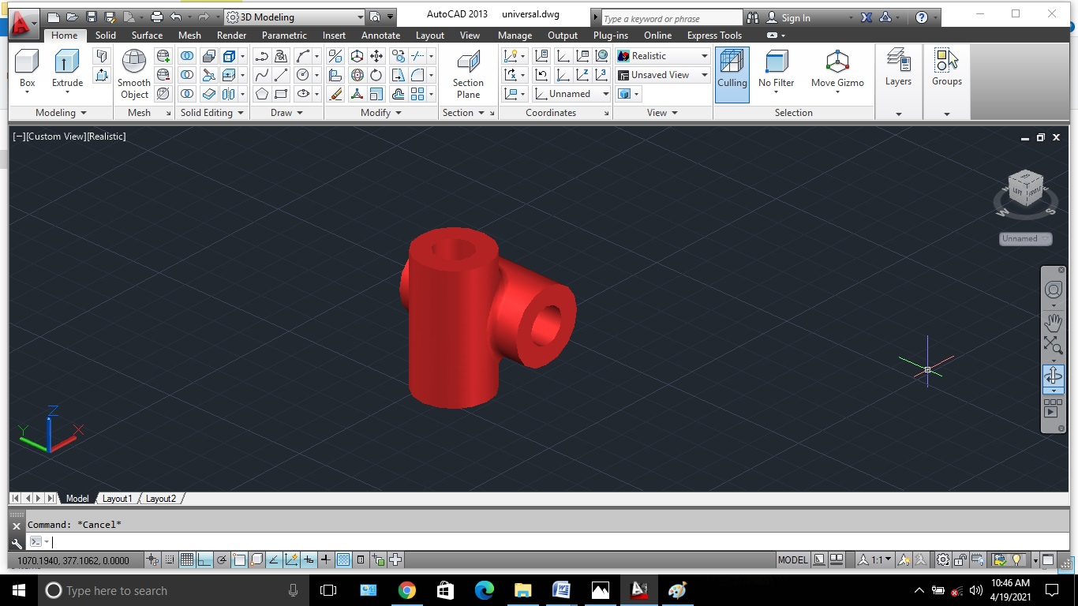

***3.Shaft:-***

1. Change the view as “Right”
2. Draw a circle of diameter 30mm
3. Draw a horizontal line at bottom quadrant and also draw a vertical line
4. Offset the vertical line on both side at a distance 4mm
5. Offset the horizontal line at a distance 26mm on upper side
6. Delete extra line.
7. Trim unwanted portions.
8. Change the view as “SE Isometric”
9. Presspull the circle of length 90mm
10. Presspull keyway position up to length 30mm
11. Delete the 2D drawing
12. Chamfer the edge of distance(2mm,2mm)
13. Fillet the keyway of radius 3mm
14. 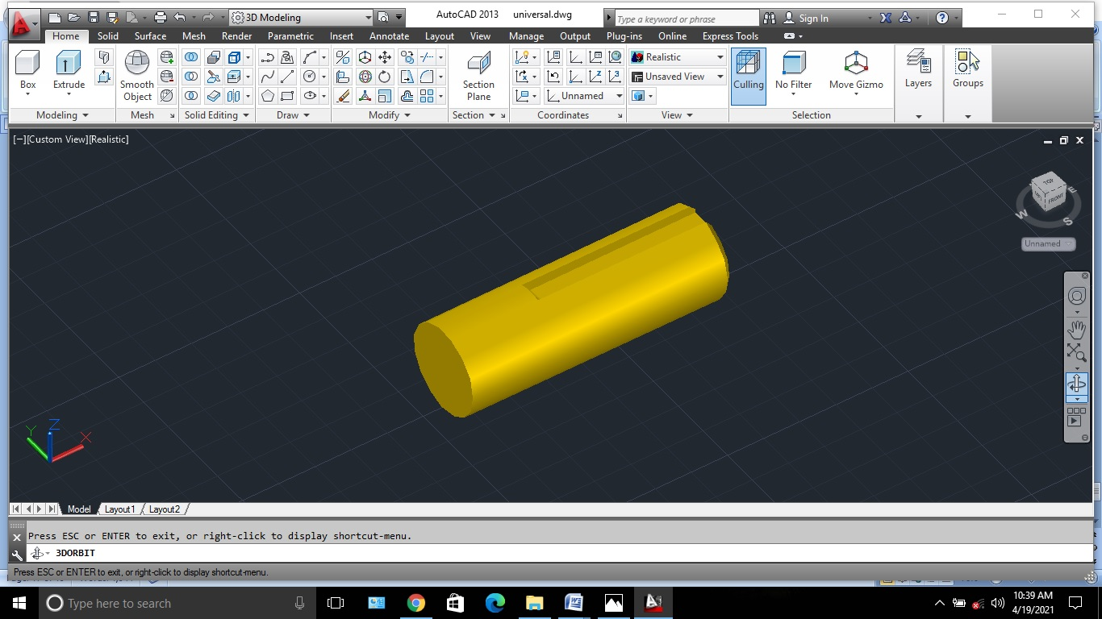Change the color to “Satin Gold.”

***4.Key:-***

1. Draw a box of length 56mm and width 8mm and height 7mm
2. Change the color to “Satin Violet.”

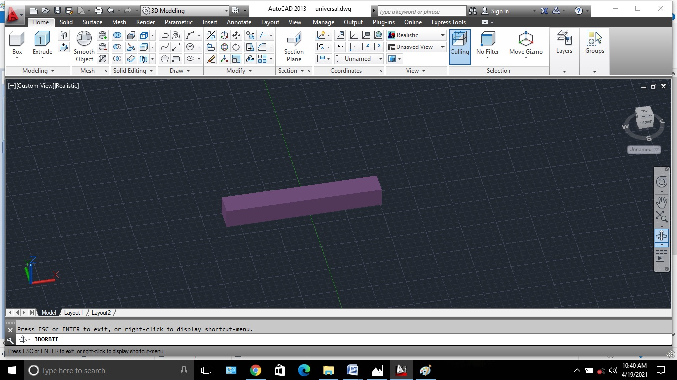

***5.Pin:-***

1. Draw a circle of diameter 25mm
2. Draw another circle of diameter 16mm
3. Presspull the small circle of height 105mm
4. Presspull the subtract zone of height 9mm
5. Union the object
6. Draw another cylinder of diameter 3mm as suitable position of any suitable height
7. Rotate the cylinder at 90o
8. Move the cylinder of base the center to the top face of pin
9. Move the cylinder below the 7mm
10. Subtract the cylinder from the pin to remove material
11. Change the color to “Satin Misty Rose.”

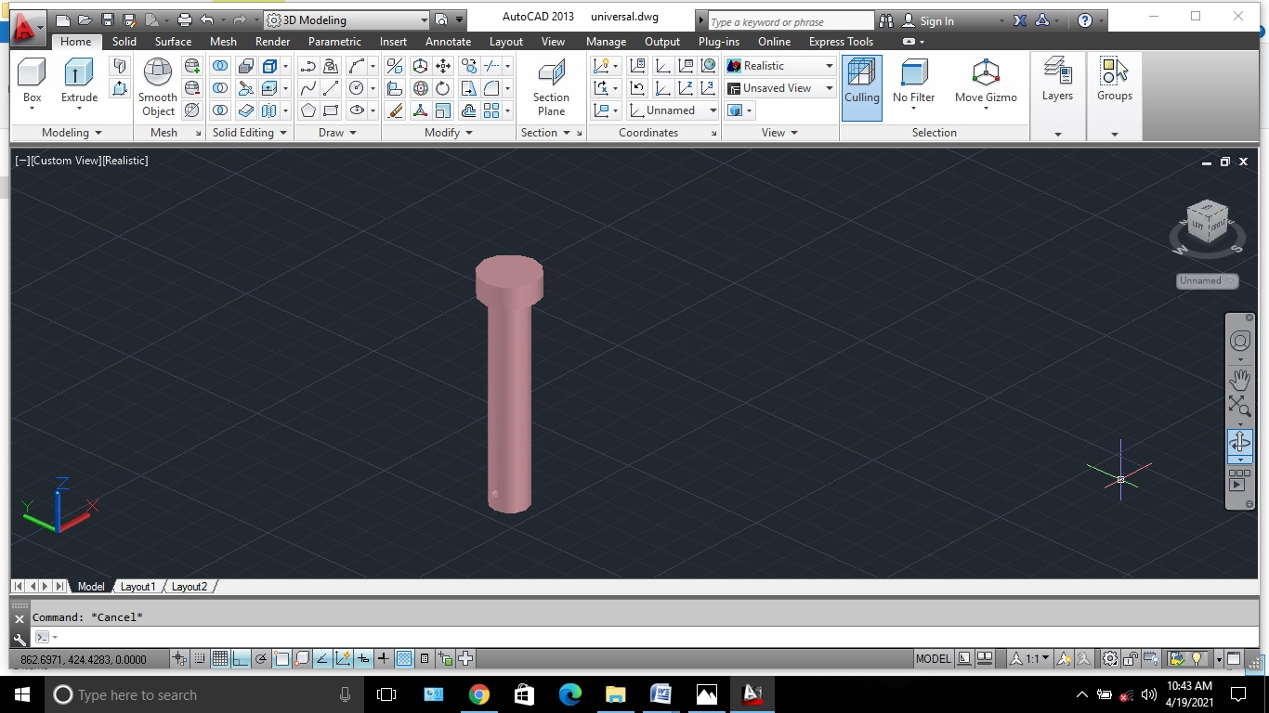

***6.Collar:-***

1. Draw a circle of diameter 25mm
2. Draw another circle as the same centre of diameter 16mm
3. Presspull the subtract position of height 10mm
4. Draw another cylinder of diameter 3mm of any suitable height at any desire position
5. Rotate the cylinder AT 90O
6. Move the cylinder at the base of centre point to the top of the collar
7. Move the cylinder below to 5mm
8. Subtract the cylinder from the collar to remove the material
9. Change the color to “Flaked Satin Dark Blue”

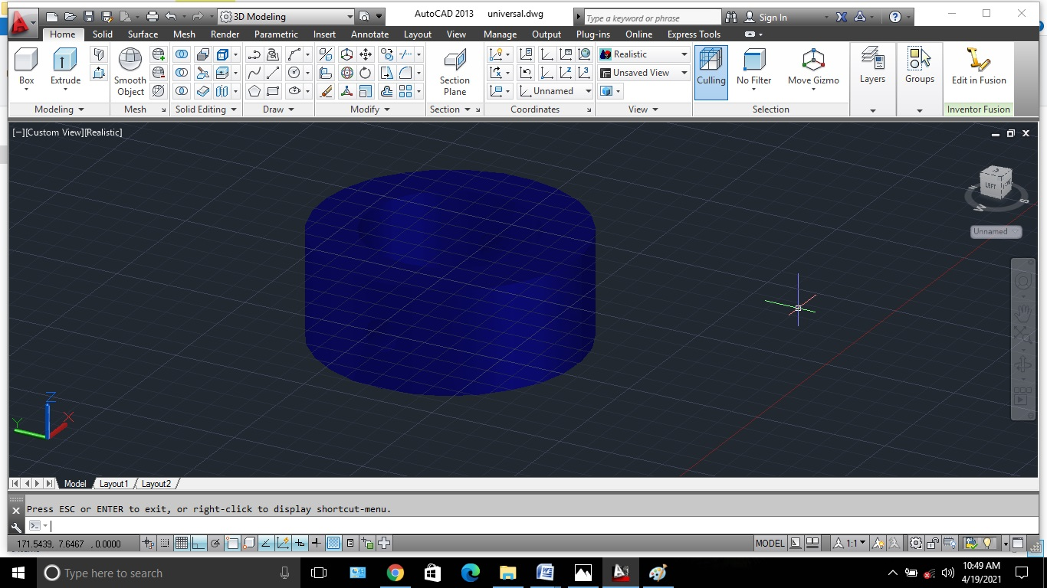

***7.Taper Pin:-***

1. Change the view as “Top”
2. Draw a line of length 30mm at any suitable position
3. Draw a circle of centre at the end point of the line of diameter 4mm and draw another circle to the centre as another end point of the line
4. Draw tangent on upper of the circles
5. Trim extra unwanted lines
6. Type “Boundary”→Select pick point→select object type as “Region”→Ok
7. Move the object to any desired position
8. Revolve the object as the centre of end point
9. Change the color to “Glossy Sienna”

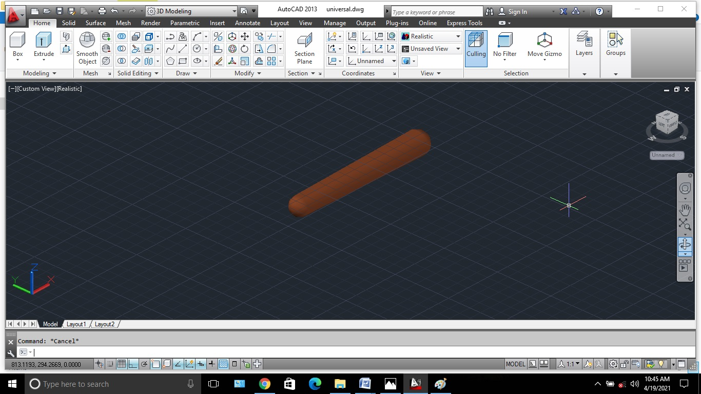

***PROJECT PICTURES:-***

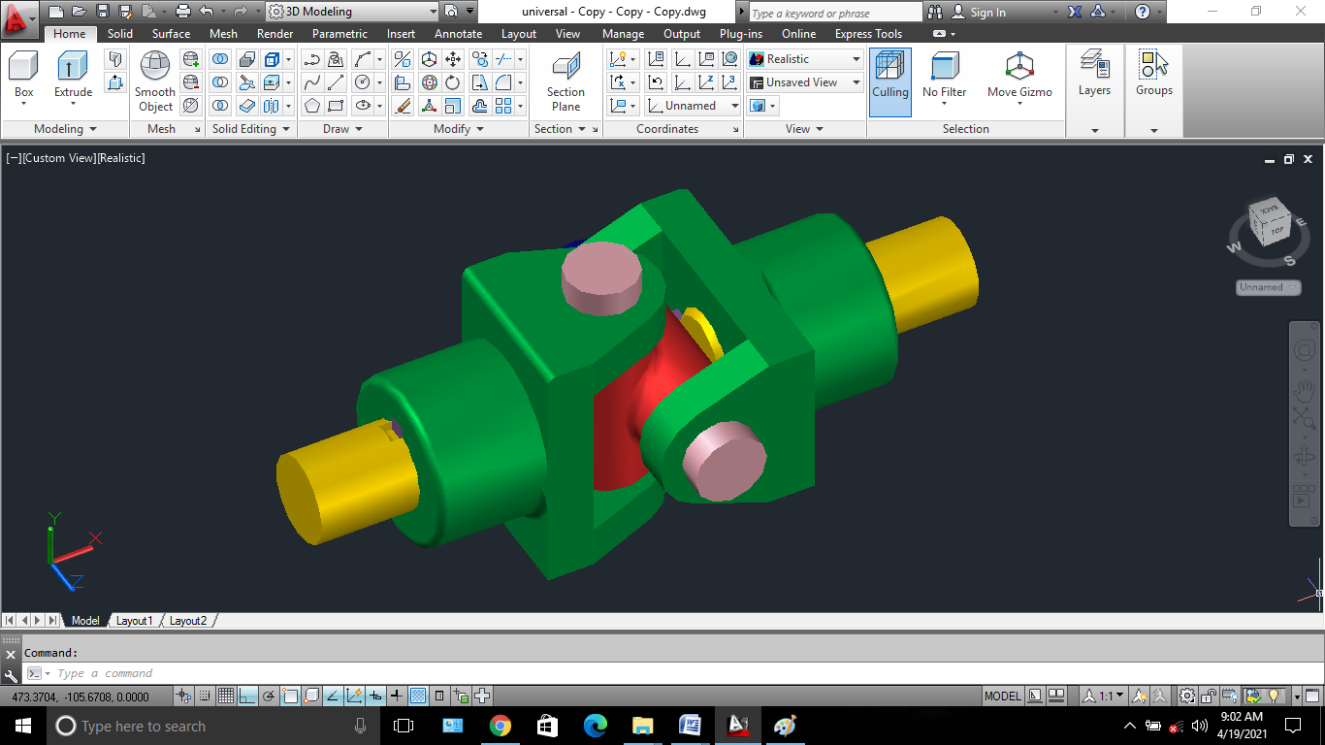

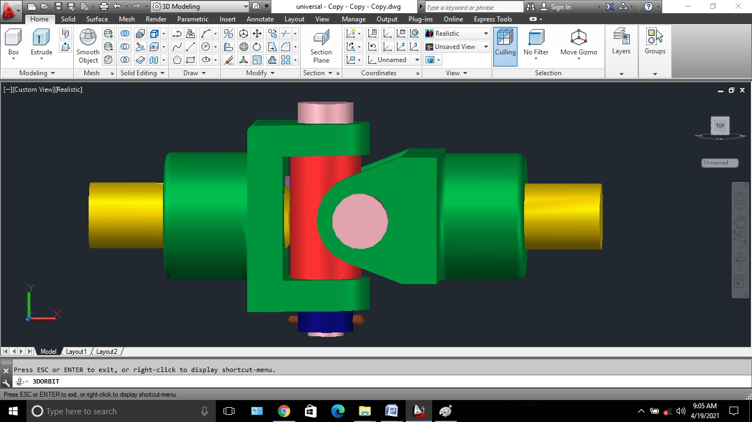

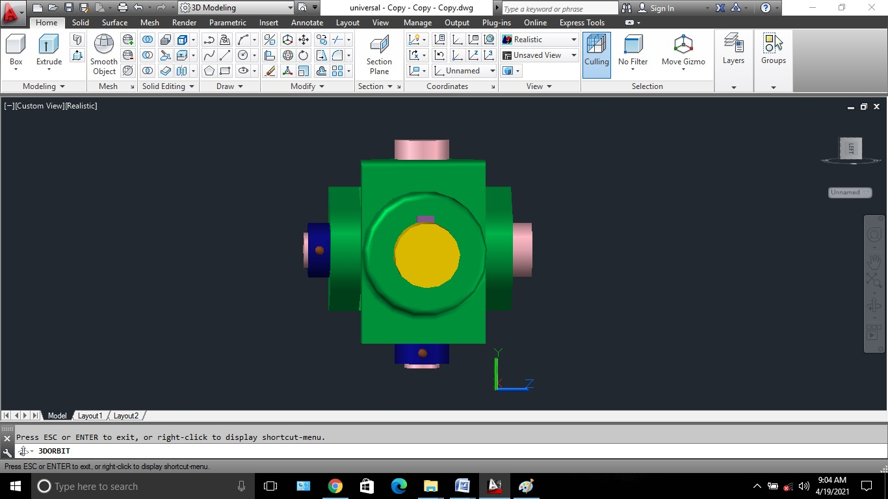

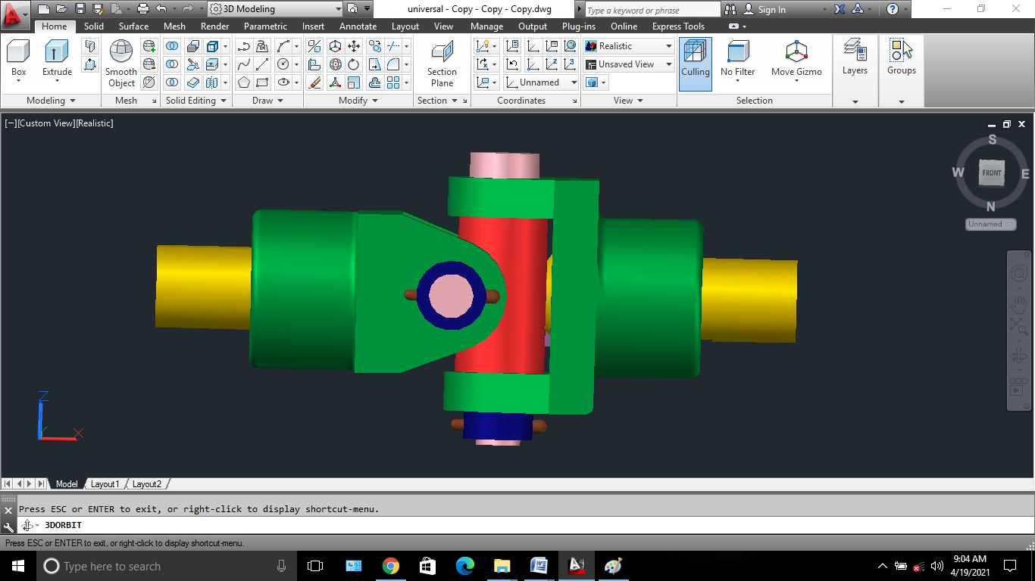

***CONCLUSION:***

In this project I have designed the part diagrams of the universal joint and made the assembly of these components. Structural analysis has been performed on the universal joint to find the defects in the formation of universal joint. Analysis was done by considering the two different materials structural steel and stainless steel has found to be having more deformation while compared to others. Structural steel is good material for this design.